Project 1 – Railways Gauges
Requirement of the projects are, Basic Data Loading & Cleaning, Simple Visualization, Filtering + Bar Chart, Feature Engineering + Pie Chart, Advanced Analysis + Multiple Graphs which must cover Data Preprocessing, Pandas Operations, NumPy Calculations and Visualization using Line graph, Bar chart, Pie chart and Stacked chart.
Program Workflow:
The very first step is to create a proper directory structure having main.py file along with the dataset railway_gauges.csv in the same folder. If both are in different paths, change the path in the code as and when required.
Before typing code, we need to import pandas, numpy and pyplot to the main python file.
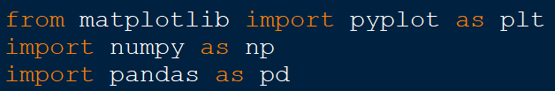
In the above code, matplotlib(pyplot is the sub-module of matplotlib), numpy and pandas are the module names which are required to perform operations as requested. plt, np and pd are the aliases of module names for using convention.

To change the given dataset to pandas DataFrames, we are using the code as shown below.
In the above code,
df => variable name for storing/accessing DataFrame.
read_csv => panda function to read the data from CSV file.

In pandas, to view the top 5 rows from a dataset we can use head() function. We can use the head function as shown below.
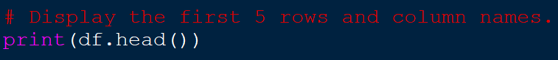
The above code will give you the output of top 5 rows from the given dataset along with the column names and the index values which is 0 to 4(n-1) as shown below.
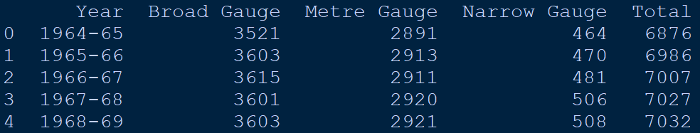
In pandas, to check if a DataFrame object have NaN(Not a Number) in any rows we can use isnull() function. Basically this function is used to check for empty or missing values from a table or dataset. It will check each cell and returns True if the cell is empty and False if the cell has some data.
Along with isnull() we can use sum() function to calculate the total number of cells having NaN value or empty cells.
If we have any missing values in the given dataset, we can replace those cells with 0(Zero) by using

